**FORMAL REPORT: MALARIA CASES IN AFRICA FROM 2007 – 2017.**

This report presents a comprehensive analysis of population distribution, malaria trends, preventive measures, and sanitation coverage. It discusses key insights derived from the data and evaluates how these findings can inform decision-making and guide further investigations.

**METHODOLOGY USED:**

**1.Data Collection and Cleaning:**

* The raw dataset likely included malaria case statistics, population demographics, and healthcare services by country over the specified period.
* Data cleaning techniques

**2.Data Aggregation:**

* Summation and averages were calculated for variables like malaria incidence, reported cases, rural/urban population, and healthcare interventions.
* Grouping data by year, country, and category (e.g., rural population) helped create detailed trends and comparisons.

**3.Visual Design:**

* Key performance indicators (KPIs) were created for high-level summaries (e.g., total countries analyzed, average malaria cases reported).
* Chart types such as line graphs, bar charts, and donut charts were used to visualize trends, distributions, and proportions effectively.

**4.Insights Derivation:**

* Trends in malaria cases, rural/urban population distributions, and healthcare interventions were analyzed to identify high-risk countries and areas requiring focus.

**DASHBOARD.**

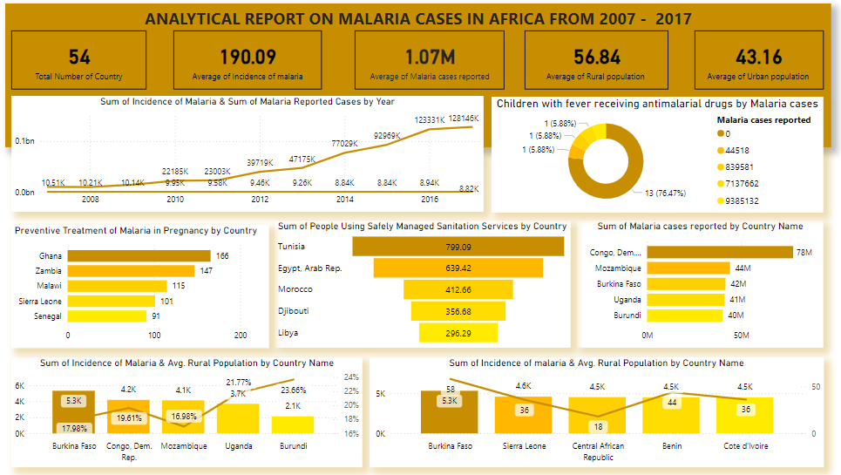

**KEY INSIGHTS, HOW THE HELP IN DECISION -MAKING AND FURTHER IPLICATION.**

**1. Population Context: Rural and Urban Distribution** **Insight:** The average rural population constitutes 56.84% of the total population, while the urban population accounts for 43.16%.

**Implications for Decision-Making:**

* **Healthcare Infrastructure:** With a higher proportion of the population living in rural areas, there is a need to prioritize healthcare services and outreach programs in these regions.
* **Resource Allocation:** Rural areas may require more targeted investments in public health initiatives, transportation, and communication to address potential disparities.
* **Further Investigation:** Analyzing variations in health outcomes between rural and urban populations to assess the impact of access disparities on disease prevalence and treatment.

**2. Sum of Incidence of Malaria & Sum of Malaria reported cases by Year:** Reported malaria cases significantly increased from 2007 to 2017, peaking at 1.28 million cases in 2017. A steady rise in incidence rates was observed between 2008 and 2016.

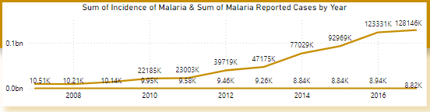

**Implications for Decision-Making:**

* **Enhanced Surveillance:** The increase in reported cases may indicate improved reporting systems or worsening conditions, necessitating a deeper review of data collection practices.
* **Policy Adjustments:** Governments should assess the effectiveness of existing malaria control programs and consider scaling up interventions.
* **Further Investigation:** Research into the factors driving this increase, such as environmental changes, vector resistance, or population growth in malaria-endemic regions.

**3. Preventive Treatment of Malaria in Pregnancy by country:** Ghana leads in providing preventive malaria items for pregnant women (166 cases), followed by Zambia (117), Malawi (115), Sierra Leone (101), and Senegal (91).

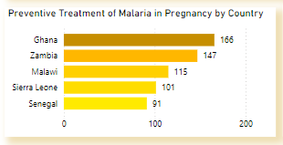

**Implications for Decision-Making:**

* **Best Practices:** Ghana’s strategies for preventive treatment can be studied and adapted in other countries to improve maternal health outcomes.
* **Resource Distribution:** Focus on countries with lower rates of preventive treatment to enhance coverage and reduce maternal and neonatal mortality rates.
* **Further Investigation:** Comparative studies on policy frameworks and their implementation success in countries with high and low preventive treatment rates.

**4. Children Receiving Antimalaria drugs by Malaria Cases:** While 76.47% of children with fever receive antimalarial drugs, 23.53% do not receive treatment.

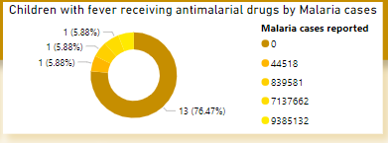

**Implications for Decision-Making:**

* **Access Barriers:** Identifying and addressing barriers to antimalarial treatment for children, such as affordability, availability, or lack of awareness.
* **Equity in Healthcare:** Tailored interventions to ensure underserved populations are reached.
* **Further Investigation:** Detailed analysis of demographic, geographic, and socioeconomic factors affecting access to antimalarial treatment.

**5. Safety Managed Sanitation by Country:** Tunisia has the highest sanitation coverage (799.09), followed by Egypt (639.42) and Morocco (412.66).

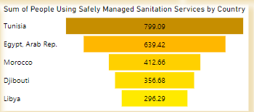

**Implications for Decision-Making:**

* **Public Health Investments:** Countries with lower sanitation coverage need prioritized investments in water and sanitation infrastructure.
* **Benchmarking Success:** Tunisia’s approach to achieving high sanitation coverage can serve as a model for other countries.
* **Further Investigation:** Evaluating the relationship between sanitation coverage and health outcomes to quantify the impact of sanitation improvements.

**6. Incidence of Malaria & Avg. Rural Population by Country:** A correlation exists between rural population percentages and malaria incidence. Countries with higher rural populations tend to have higher malaria cases. Burkina Faso recorded the highest rural population (17.98k), resulting in 5.8k malaria cases, followed by the Congo Republic, Mozambique, Uganda, and Burundi.

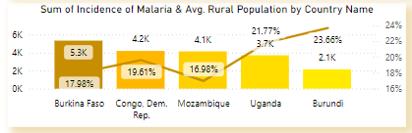

**Implications for Decision-Making:**

* **Targeted Interventions:** Countries with larger rural populations should receive focused malaria prevention efforts, including vector control and education campaigns.
* **Healthcare Accessibility:** Addressing gaps in healthcare access and improving rural infrastructure can reduce incidence rates.
* **Further Investigation:** Explore the link between rural living conditions, healthcare access, and disease spread.

**7. Incidence of Malaria & Avg. Urban Population by Country:** Burkina Faso recorded the highest urban population (5.3k) with 58 malaria cases, followed by Sierra Leone, Central African Republic, Benin, and Côte d'Ivoire.

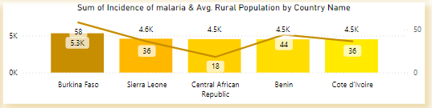

**Implications for Decision-Making:**

* **Urban Health Policies:** Despite lower incidence rates, urban areas require sustained malaria control programs to prevent outbreaks.
* **Preventive Measures:** Strengthen urban malaria surveillance and ensure access to prevention and treatment services.
* **Further Investigation:** Assess how urbanization and migration influence malaria patterns.

**8. Malaria cases reported by Country:** Congo recorded the highest malaria cases (78M), followed by Mozambique (42M), Burkina Faso (41M), and Uganda (40M).

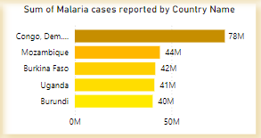

**Implications for Decision-Making:**

* **Resource Prioritization:** High-burden countries require immediate allocation of resources for treatment, prevention, and public health campaigns.
* **Regional Collaboration:** Encourage collaboration between high-incidence countries to share strategies and resources.
* **Further Investigation:** Identify factors contributing to high case numbers in specific countries and evaluate intervention effectiveness